1. Create the following page section using HTML and external CSS (no inline styles). Use a table or a definition list (in this case the layout will be different).

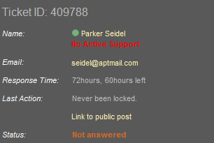

1. Create the following Web page using external CSS styles.

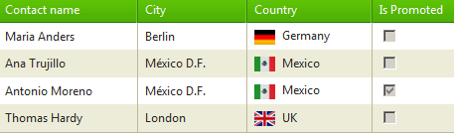

1. Create a web page using the   
   homework-3.png design and the HTML markup in homework-3.html.